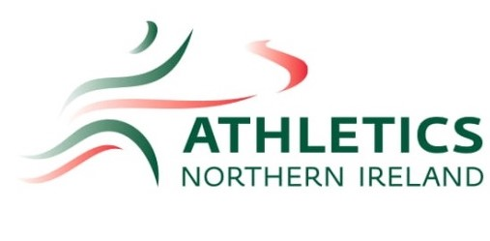
TEAM TROPHY and OPEN GRADED MEETING 2024 formation Sheet
Sunday 26th May 2024, Mary Peters Track

This is an interclub Team Trophy competition with an open graded competition running in parallel.
Rules of Competition:
Team Trophy
- This is a SENIOR competition open to all competitors from Under 17 and up.
- All implements/hurdles will be senior weights/specifications only
- Clubs wishing to score in the Team Trophy competition must be affiliated to Athletics Northern Ireland.
- No Entries on the day
- NI affiliated clubs taking part in the Team Trophy must complete paper entry and submit by 5pm Friday 17th May .
- All clubs must provide two named volunteers (in addition to ANI Officials) to assist at field events.
- £8 per athlete (max 3 events)
Open Graded
- This is a senior competition
- Masters are welcome to enter and use appropriate Masters age group implements / hurdles
- Athletes must enter as individuals via Open Track system Entry fee £8 for unlimited number of events. Entries close on 13th May.
- Club vests must be worn
- No Entries on the day.
Events:
Women – 100m, 200, 400m, 800, 1500m, 3000m, 100mH, 400mH, 4x100m, 4X400m
Long Jump, Triple Jump, High Jump, Shot, Javelin, Discus, Hammer
Men - 100m,200, 400m, 800, 1500m, 3000m, 110mH, 400mH 4x100m, 4x400m,
Long Jump, Triple Jump, High Jump, Shot, Javelin, Discus, Hammer
Field Events
- All competitors will be allowed four attempts in throws and horizontal jumps.
- All personal implements must be weighed in before the competition starts.
No more than two competition implements per athlete per event.
Track Events
- Events on the track may be seeded.
- In track events comprising more than one race the best 8 eligible performances will score.

Team Trophy Scoring Rules
- A maximum of two athletes from each club affiliated to Athletics Northern Ireland can score in any event towards the Team Trophy Competition.
- The first 8 eligible athletes will score points in each event.
- Scoring - 9, 7,6, 5, 4, 3, 2, 1
- The winning Men’s and Women’s Teams will each be awarded a Team Trophy to be held by the club for one year

All enquiries, please contact: info@athleticsni.org

Athletics Northern Ireland
Old Coach Road,
Belfast, BT79 5PR

